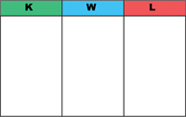
Supporting Evidence: (Examples, data/statistics, locations)
*

*

*

*

1967 Referendum: What? Why?
- What?

- Why?

1967 Referendum
1967 Referendum - Clips (Key Information)
*

*

*

*

*

*

*

*
This Photo by Unknown Author is licensed under CC BY-NC-ND


Why was this event significant?
*

*

*
Define ‘referendum’
Key Question: Outline what the 1967 Referendum was about and provide various reasons why it was significant. (Do on file paper if you need more space)

